API Test Cases Execution

Version 1.0

Author – Sudhahar Vaithilingam

|  |  |
| --- | --- |
| **API** | **Purpose** |
| http://localhost:11016/retail/api/login{name} | Login & check the status |
| http://localhost:11016/retail/api/topup | Top-up to the customer |
| http://localhost:11016/retail/api/pay | Pay customer to customer |

**Case 1 : login Alice**

End Point - <http://localhost:11016/retail/api/login?name=Alice>

**Response:**

{

    "name": "Alice",

    "balance": 0.0,

    "oweTo": **null**,

    "oweToAmount": 0.0,

    "oweFrom": **null**,

    "oweFromAmount": 0.0

}

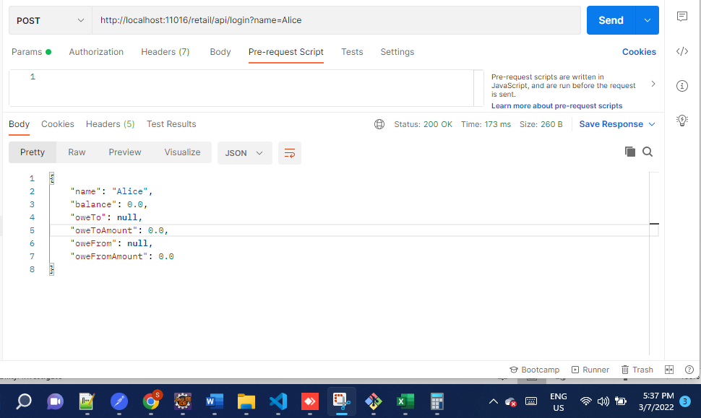

**Case 2 : topup 100(Alice)**

**URI -** <http://localhost:11016/retail/api/topup>

|  |  |
| --- | --- |
| **Request** | **Response** |
| {      "name": "Alice",      "amount": 100  } | {      "name": "Alice",      "balance": 100.0,      "oweTo": **null**,      "oweToAmount": 0.0,      "oweFrom": **null**,      "oweFromAmount": 0.0  } |

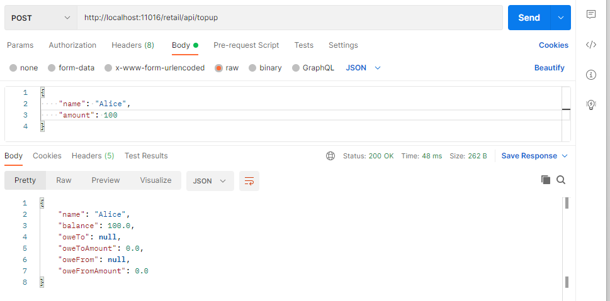

**Case 3 : login Bob**

End Point - <http://localhost:11016/retail/api/login?name=Bob>

Response

{

    "name": "Bob",

    "balance": 0.0,

    "oweTo": **null**,

    "oweToAmount": 0.0,

    "oweFrom": **null**,

    "oweFromAmount": 0.0

}

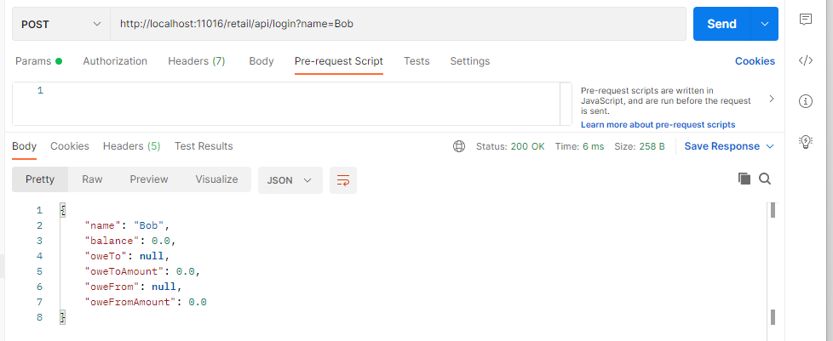

**Case 4: topup 80(Bob)**

End Point – <http://localhost:11016/retail/api/topup>

|  |  |
| --- | --- |
| **Request** | **Response** |
| {      "name": "Bob",      "amount": 80  } | {      "name": "Bob",      "balance": 80.0,      "oweTo": **null**,      "oweToAmount": 0.0,      "oweFrom": **null**,      "oweFromAmount": 0.0  } |

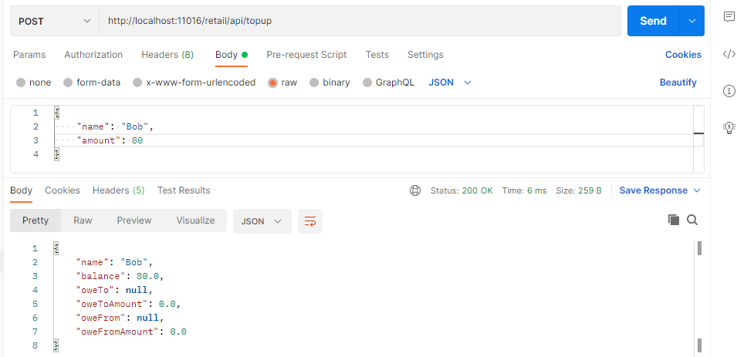

**Case 5 : pay Alice 50**

End Point - <http://localhost:11016/retail/api/pay>

|  |  |
| --- | --- |
| **Request** | **Response** |
| {      "name": "Bob",      "amount": 50,      "payTo": "Alice"  } | {      "name": "Bob",      "balance": 30.0,      "oweTo": **null**,      "oweToAmount": 0.0,      "oweFrom": **null**,      "oweFromAmount": 0.0  } |

Bob 80 Reduced to 30

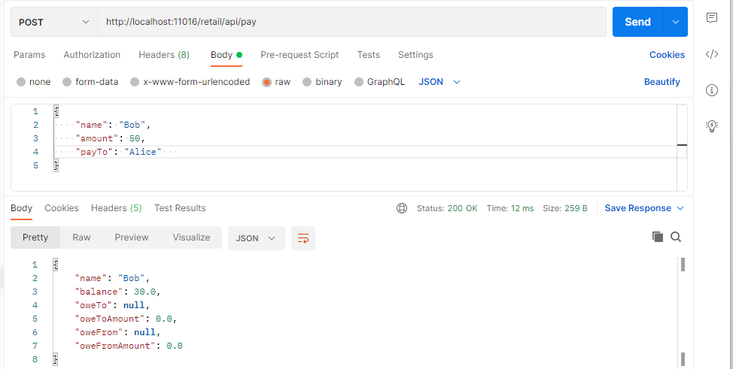

Alice 100 increase to 150

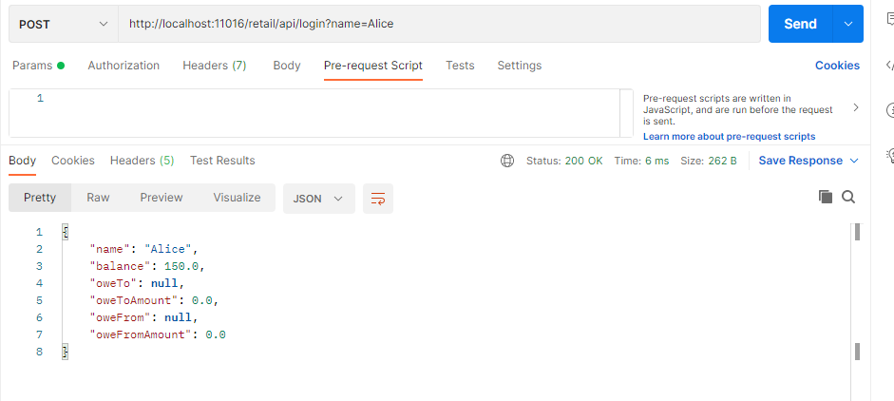

**Case 6: pay Alice 100**

|  |  |
| --- | --- |
| **Request** | **Response** |
| {      "name": "Bob",      "amount": 100,      "payTo": "Alice"  } | {      "name": "Bob",      "balance": 0.0,      "oweTo": "Alice",      "oweToAmount": 70.0,      "oweFrom": **null**,      "oweFromAmount": 0.0  } |

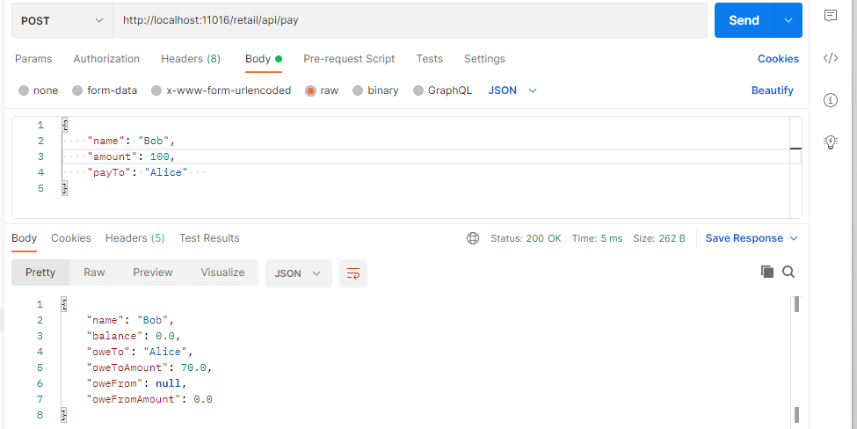

Alice Balance Status:

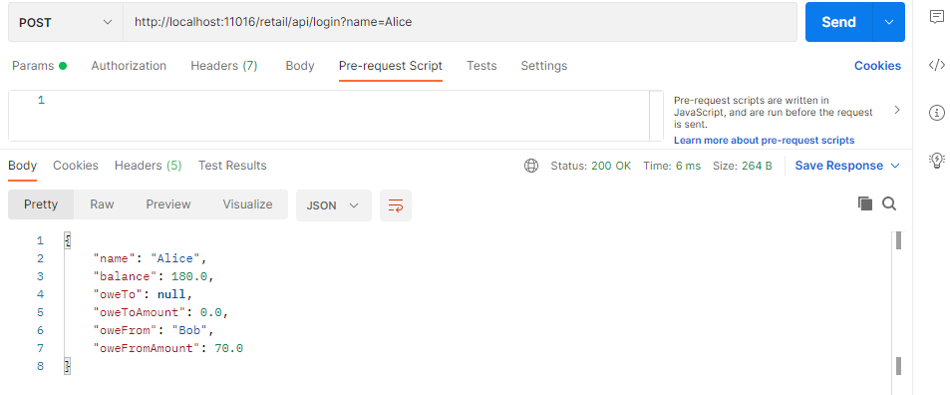

**Case 7 – Bob top up 30**

**End Point -** <http://localhost:11016/retail/api/topup>

|  |  |
| --- | --- |
| **Request** | **Response** |
| {      "name": "Bob",      "amount": 30  } | {      "name": "Bob",      "balance": 0.0,      "oweTo": "Alice",      "oweToAmount": 40.0,      "oweFrom": **null**,      "oweFromAmount": 0.0  } |

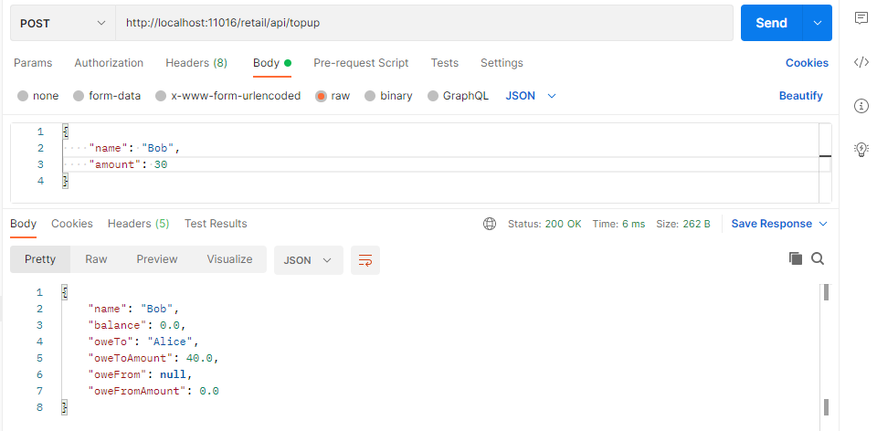

**Case 8 – Login Alice**

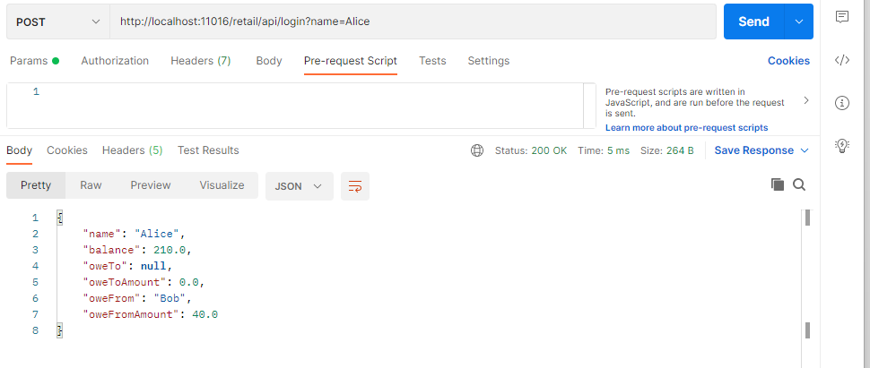

**Case 9 – Alice Pay 30 to Bob**

**End Point -** <http://localhost:11016/retail/api/pay>

|  |  |
| --- | --- |
| **Request** | **Response** |
| {      "name": "Alice",      "amount": 30,      "payTo": "Bob"  } | {      "name": "Alice",      "balance": 210.0,      "oweTo": **null**,      "oweToAmount": 0.0,      "oweFrom": "Bob",      "oweFromAmount": 10.0  } |

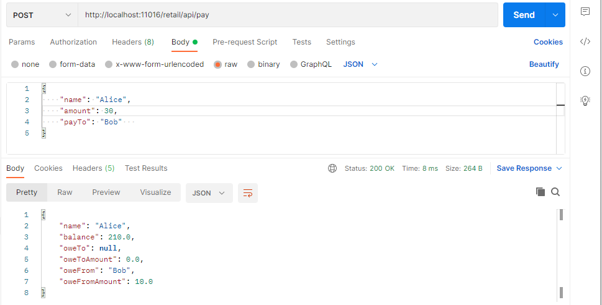

**Case 9 – Login Bob**

**End Point -** <http://localhost:11016/retail/api/login?name=Bob>

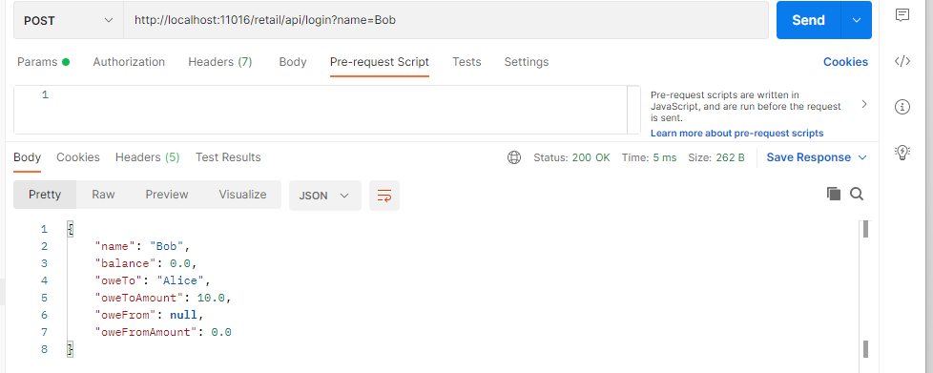

**Case 9 – Top-up 100 Bob**

**End Point -** <http://localhost:11016/retail/api/topup>

|  |  |
| --- | --- |
| **Request** | **Response** |
| {      "name": "Bob",      "amount": 100  } | {      "name": "Bob",      "balance": 90.0,      "oweTo": **null**,      "oweToAmount": 0.0,      "oweFrom": **null**,      "oweFromAmount": 0.0  } |

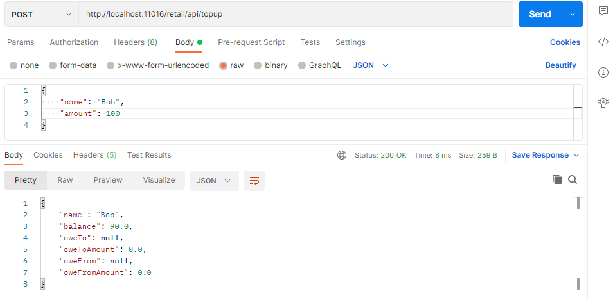

Alice Status:

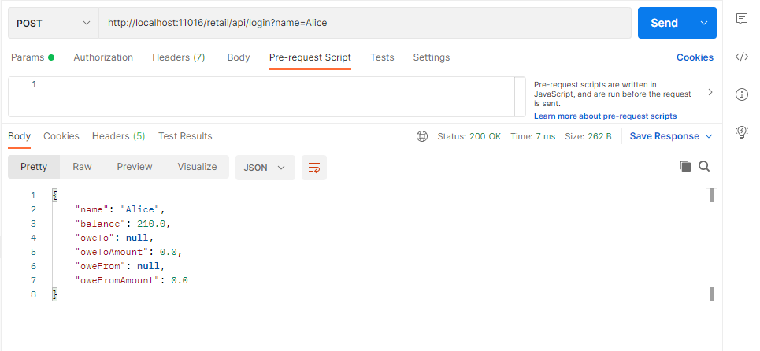

**Extra features added in to Micro Service**

1. Swagger Implementation

<http://localhost:11016/swagger-ui/index.html?configUrl=/swagger19/swagger-config>

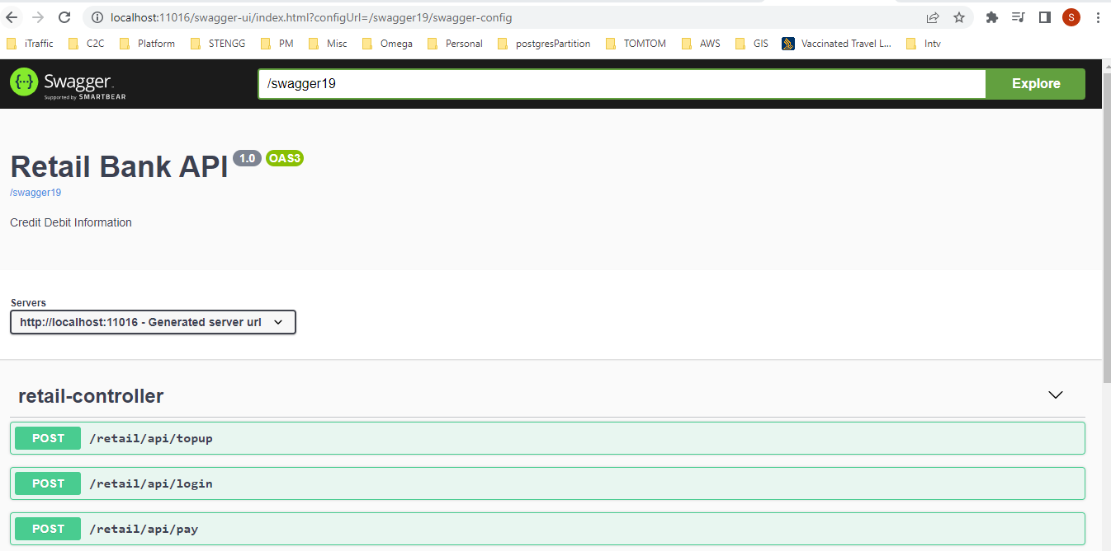

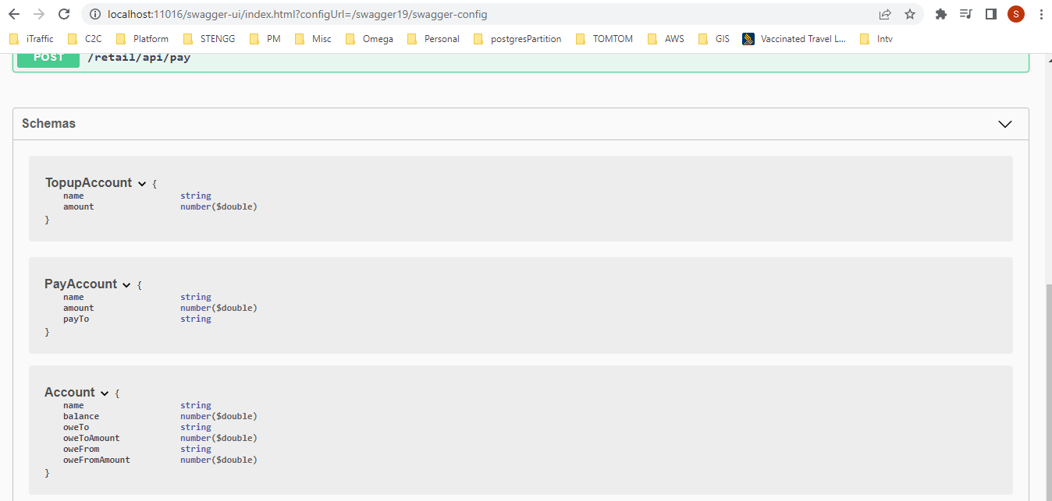

**Error! Hyperlink reference not valid.**